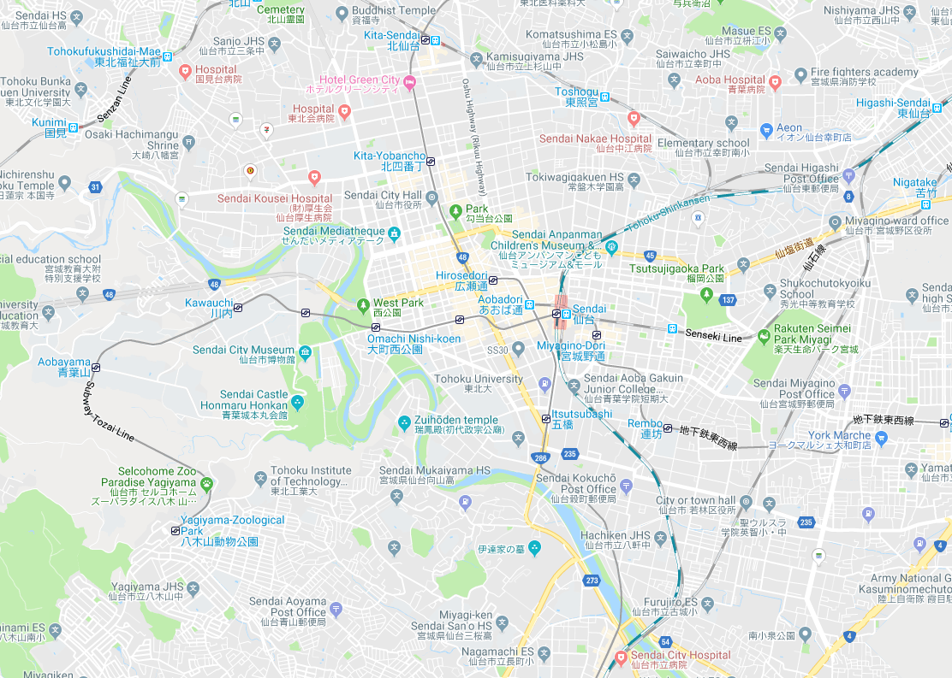
IH Higashi-
Sendai
Katahira Campus
UH Aobayama AAobayama
UH Nagamachi
Kawauchi Campus
UH Sanjo,Ⅱ,Ⅲ,
IH Sanjo
IH Sanjo2 2
Aobayama Campus
Seiryo Campus

